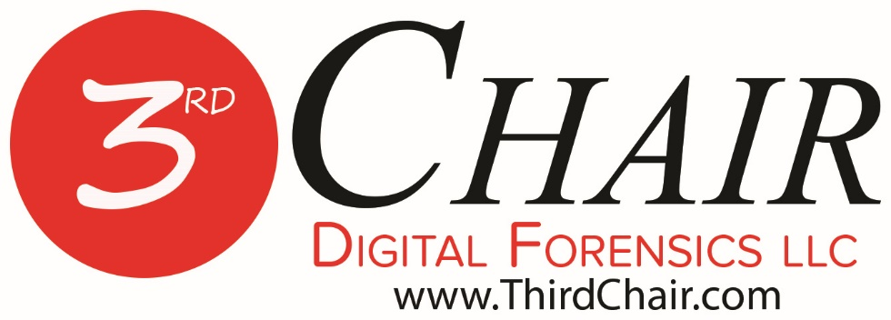
Documents filed under seal are excluded from Electronic Submission. Rule 1.3(1) - Tex. Crim. App. Misc. Order 17-005
Click to view the rules......

Thank you for considering Third Chair Digital Forensics LLC. We stand ready to assist you and your clients.

For this particular order we have found that we will need three copies of the order certified by the Clerk’s Office.
- For Our Records and Payment Later with the County Auditor
- One to present to the Law Enforcement Agency (LEA) to check out the evidence for testing.
- One to return with the evidence when the testing is complete.

Raised Seal Orders Work Best. The LEAs teach their property room staff to look for that Raised Seal for the Official Court Orders. A little carbon paper rubbed across the seal make is stand out on any quality scanner.

Orders can be sent via e-mail, fax, mail or we can pick it up if you are local. Orders@ThirdChair.com

Should you ever have any questions, please do not hesitate to contact us.

Third Chair Digital Forensics LLC
2502 Gravel Drive
Fort Worth, Texas 76118
817-953-3385
817-554-1534 fax

No. _________________
THE STATE OF TEXAS | § | IN THE _____ JUDICIAL
 | §
VS. | § | DISTRICT COURT OF
 | §
____________________________ | § | ___________ COUNTY, TEXAS

EX PARTE MOTION FOR DEFENDANT’S ACCESS TO PHYSICAL EVIDENCE
FILED UNDER SEAL

(The Clerk of the Court is ORDERED to seal this Motion in the file)
TO THE HONORABLE JUDGE OF SAID COURT:
COMES NOW, the Defendant in the above-styled and numbered cause, by and through his attorney of record, (name of Defendant’s attorney of record), and files this Ex Parte Motion for Defendant’s Access to Physical Evidence; and in support thereof would show this Honorable Court as follows:
I.
In the instant case, the Defendant is charged with the offense of (offense for which Defendant charged).
II.
At the time of the Defendant’s detention on this charge, officers of the (name of law enforcement agency) took certain evidence from the Defendant, to wit: (evidence taken or recovered).
III.
A compelling need exists in this case for the Defendant to perform his own forensic testing on the above-noted physical evidence in order to address a significant issue at trial. Counsel for Defendant does not wish to specifically delineate the type of forensic testing to be performed on the evidence because doing so will compromise the defense in the instant case.
IV.
The Defendant has retained the services of THIRD CHAIR DIGITAL FORENSICS LLC to perform the necessary testing. In order for said law enforcement agency to release the physical evidence in question to the Defendant for independent testing, a Court Order is necessary.
WHEREFORE, PREMISES CONSIDERED, the Defendant hereby requests that the Court grant an in camera hearing on this Motion in the instant cause; and that subsequent to the hearing on said Motion that the Court ORDER that the evidence in question be released to THIRD CHAIR DIGITAL FORENSICS LLC so that further forensic testing can be done for the preparation and trial of this case.

Respectfully submitted,

______________________________
ATTORNEY FOR DEFENDANT

FIAT
IT IS HEREBY ORDERED that the above Motion be heard in camer on the ______ day of ________________, 201____, at ________________ o’clock ___m.

____________________________
JUDGE PRESIDING

CERTIFICATE OF SERVICE
I hereby certify that no copy of this Motion was delivered to the (name of county) County District Attorney’s Office, attorneys for the State of Texas, because Defense Counsel wishes to proceed ex parte on said Motion.

______________________________
ATTORNEY FOR DEFENDANT

No. _________________
THE STATE OF TEXAS | § | IN THE _____ JUDICIAL
 | §
VS. | § | DISTRICT COURT OF
 | §
____________________________ | § | ___________ COUNTY, TEXAS
ORDER TO ALLOW DEFENSE TESTING OF EVIDENCE
FILED UNDER SEAL

The above and foregoing Defendant’s Motion For Access To Physical Evidence having been heard by the Court and the Court having considered such Motion, it is hereby ORDERED that the Motion be GRANTED.
IT IS THEREFORE, ORDERED, ADJUDGED, AND DECREED that (name of agency holding the evidence to be tested) must release (evidence to be tested) to THIRD CHAIR DIGITAL FORENSICS LLC for testing at the discretion of Defendant.
IT IS FURTHER ORDERED, ADJUDGED, AND DECREED that the above-described evidence to be tested, be transferred from the law enforcement agency currently holding said evidence to an authorized employee or representative of THIRD CHAIR DIGITAL FORENSICS LLC, in a manner sufficient for maintaining the integrity and chain of custody of the evidence.
IT IS FURTHER ORDERED, ADJUDGED, AND DECREED that the evidence to be tested, be returned to the law enforcement agency, by an authorized employee or representative of THIRD CHAIR DIGITAL FORENSICS LLC, in a manner sufficient for maintaining the integrity and chain of custody of the evidence within the period of time specified by this ORDER for completion of testing of the evidence.
IT IS FURTHER ORDERED, ADJUDGED, AND DECREED that any testing of the evidence to be tested that the Defendant wishes to conduct will be completed within (period of time in which testing is ordered to be completed) of the date this ORDER is signed.
IT IS FURTHER ORDERED, ADJUDGED, AND DECREED that upon return of said evidence, the Defendant will provide to the law enforcement a true and correct copy of the chain of custody log created in accordance with the transport, testing and return of said evidence, at least thirty days prior to the date the trial of this case is scheduled to begin.

Signed this _______ of _________________, 201_____.

__________________________________
Judge Presiding

