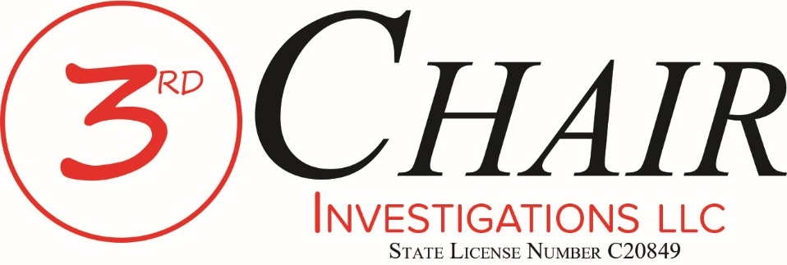
Documents filed under seal are excluded from Electronic Submission. Rule 1.3(1) - Tex. Crim. App. Misc. Order 17-005
Click to view the rules......

Thank you for continuing to use Third Chair Investigations LLC.

If you are using this motion, we have already developed a relationship with the Client and your defense team.

This motion allows us to re-load to funding source with the Court. We have reached a point where we need to expand our work based upon your direction and guidance. To do that we must get pre-approval for the expenditure from the Court.

Once presented and approved by the Court, please send the order to Orders@ThirdChair.com or fax to 817-554-1534.

Should you ever have any questions, please do not hesitate to contact us.

Third Chair Investigations LLC
State License No. C20849
2502 Gravel Drive
Fort Worth, Texas 76118
817-953-3385
817-554-1534 fax

No. _________________
THE STATE OF TEXAS | § | IN THE _____ JUDICIAL
 | §
VS. | § | DISTRICT COURT OF
 | §
____________________________ | § | ___________ COUNTY, TEXAS

DEFENDANT’S EX PARTE MOTION FOR APPROVAL OF ADDITIONAL FUNDS FOR INVESTIGATIVE SERVICES
FILED UNDER SEAL

(The Clerk of the Court is ORDERED to seal this Motion in the file)

TO THE HONORABLE JUDGE OF SAID COURT:

COMES NOW, the Defendant in the above-styled and numbered cause, by and through his attorney of record, (name of Defendant’s attorney of record), and files this Ex Parte Motion for Approval of Additional Funds For Investigative Services; and in support thereof would show this Honorable Court as follows:
I.
In the instant case, the Defendant is charged with a felony. The Defendant has been found to be indigent and remains indigent. Undersigned counsel was court-appointed to represent the Defendant. The Court has previously approved the expenditure of funds in the amount of $(amount of funds) for investigative services.
II.
Counsel’s review of the facts of the instant case reveals that it is necessary to the effective defense of the case to conduct further investigation. Counsel for Defendant has determined that additional investigation in this case will be approximately $(amount of additional expense). Counsel therefore requests that the Court approve additional payment not to exceed this amount when the additional investigation has been performed by THIRD CHAIR INVESTIGATIONS LLC, Texas License No. C20849.
III.
A compelling need exists in this case for further investigation to address a significant issue at trial. The Defendant will be irreparably harmed if he is unable to perform a proper investigation in the preparation of this case for trial and undersigned counsel will be unable to render effective assistance of counsel.
IV.
WHEREFORE, PREMISES CONSIDERED, the Defendant hereby requests that the Court grant an ex parte hearing on this Motion in the instant cause; and that subsequent to the hearing of said Motion that the Court ORDER the approval of additional funds to THIRD CHAIR INVESTIGATIONS LLC, Texas License No. C20849 to assist the Defendant in the preparation and trial of this case.

Respectfully submitted,

______________________________
ATTORNEY FOR DEFENDANT

FIAT
IT IS HEREBY ORDERED that the above Motion be heard on the ______ day of ________________, 201____, at ________________ o’clock ___m.

____________________________
JUDGE PRESIDING

CERTIFICATE OF SERVICE
I hereby certify that no copy of this Ex Parte Motion was delivered to the (name of county) County District Attorney’s Office, attorneys for the State of Texas, because Defense Counsel wishes to proceed ex parte on said Motion.

______________________________
ATTORNEY FOR DEFENDANT

No. _________________
THE STATE OF TEXAS | § | IN THE _____ JUDICIAL
 | §
VS. | § | DISTRICT COURT OF
 | §
____________________________ | § | ___________ COUNTY, TEXAS

O R D E R
The above and foregoing Defendant’s Motion for Additional Funds For Investigative Services having been heard by the Court, and the Court having considered such Motion, it is hereby ordered that the Defendant’s Motion be GRANTED.
The Court further ORDERS that additional funds for digital forensic analysis to assist the Defendant in the preparation and trial of the instant case be approved in the amount of $(amount approved) to THIRD CHAIR INVESTIGATIONS LLC, Texas License No. C20849.
The Court further ORDERS that the Defendant’s Motion and this ORDER be sealed for the record and that no access to same be allowed to any person without prior approval of the Court.
SIGNED on this the ____ day of _________________, 201__.

___________________________
JUDGE PRESIDING

Third Chair Investigations LLC
EIN: 81-2982745
2502 Gravel Drive
Fort Worth, Texas 76118
817-953-3385
817-554-1534 fax
Orders@ThirdChair.com

